

**<<ACADEMIC BLOG AT FPTU>>**

**Software Requirement Specification**

–Ho Chi Minh, April 2021 –

**Table of Contents**

I. **Overview 3**

1. Introduction 3

2. System Functions 4

1. Screen Flow 4
2. Screen Details 4
3. User Authorization 7
4. Non-screen Functions 7

3. Common Requirements 8

**II. Functional Requirements 6**

1. <<Feature Name 1>> 6

a. <<Function Name 1>> 6

b. <<Function Name 2>> 6

2. <<Feature Name 2>> 6

# I. Overview

## 1. Introduction

In the digital era, information and data on the Internet are considered extremely rich knowledge resources. People can easily find information and data through this resource, however, that also brings many difficulties. Particularly, students are having difficulty in selecting the most urgent content and topics for their majors and subjects at university. In addition, students who have extracted experiences and knowledge through subjects and topics do not have the way to disseminate to the right audience - the students at university. Therefore, the Academic Blog at FPTU (ABF) was released as a solution to these problems. ABF is a website for all students of FPT University, this is a place for students to learn, gather knowledge and share experiences about their major, especially their subject. With some challenges in finding materials for research, the website is expected to provide more knowledge for students.

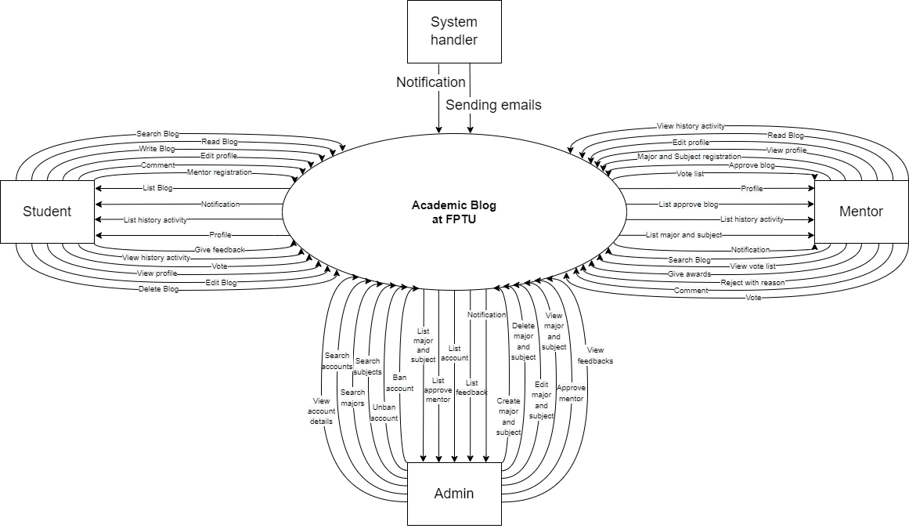

## 2. System Functions

#### A. Screen Flow

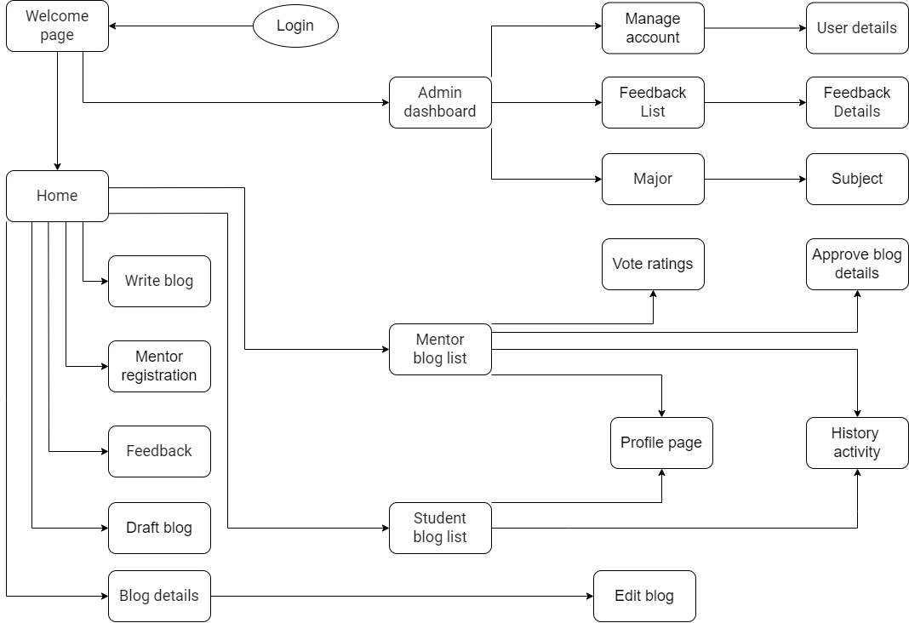

#### B. Screen Details

| **#** | **Feature** | **Screen** | **Description** |
| --- | --- | --- | --- |
| 1 | Welcome | Welcome page | On this screen, a login button appears along with images related to FPT University. Inspire people to log in so they can read their shares and write their own |
| 2 | Home page | Home | On this screen, shows a preview of featured blogs that are interactive or featured and can be clicked to view. In addition, there are places to choose to be able to write a new blog and choose to go to the feedback page. |
| 3 | Write new blog | Write blog | On this screen, this is a place for users to write up their academic experiences and share their learning experiences with people who are interested in that topic. |
| 4 | View blog | Blog details | This is the screen page, to view the details of the blog post so that the user can interact with the blog post with functions such as commenting, dropping icons, ... Along with that, the user will be able to comment on posts and viewers and if it's myblog then you have the right to edit it. |
| 5 | Edit blog | Edit Blogs | Show a page that allows users to view the blog's detailed information that has not been updated including thumbnail, title, content, video, and update date. The users can change the above information and then the “update date” will change after the users edit the blog. |
| 6 | Give Feedback | Feedback | On this screen, the page will display a form with some sections for users to assess the quality of the website. Particularly, at the top of the page, a section offers several options for the problems that students are facing. In the below section, students can write about their problems in detail. And at the bottom, the page will have a section for students to provide their suggestions that will improve the website in the future. Finally, the students need to send this form to the admin by clicking on the Submit button. |
| 7 | Admin page | Admin dashboard | On this screen, it shows what functions an administrator can administer such as: Manage account, view feedback, manage major and subject,... Here, the administrator can choose one of these functions to meet the requirements of management as well as edit and change to guide the content of the website in the future. |
| 8 | Manage account | Manage account | This screen will display the functions used to manage accounts (including students and lecturers) such as providing permissions for new teachers, removing accounts that are no longer in use or violating the rules,... |
| 9 | Feedback List | Feedback List | On this screen, a list of feedback sent by users about the system's problems or mentor's activities is displayed so that they can promptly solve problems to make the blog more complete. Along with each feedback there will be a button to view details about that feedback. |
| 10 | Feedback details | Feedback details | On this screen it will display a list of feedback from students and teachers about the system's operation and the stability of the website. |
| 11 | Manage Major | Major | This screen shows the list of managed majors. Along with the options to add, delete, edit for the displayed items. From there, there is a link to the subject page to manage specific subjects. |
| 12 | Manage Subject | Subject | On this screen, a list of subjects is displayed to attach to the user's blog posts. Along with the features: add, delete, edit, ... so that admin can manage those items. |
| 13 | Mentor page | Mentor blog list | On this screen, mentors can view and edit their information and show what functions a mentor can manage such as:View vote (view vote blog), Approve blog and as well as create a blog post |
| 14 | View vote | Vote Ratings | This screen will show the votes ratings of the blog and it has a button “Give awards” to show the pop-up give awards to the top votes ratings. |
| 15 | Approve blog | Approve blog details | On this screen, we can see a list and detailed content of blog posts such as: title, subject, subject, blog post content, .. posted by students and waiting for mentor approval. |
| 16 | Manage profile | Profile page | This function shows users’ information including their full name, gender, participating majors, and self-image (avatar), users can change the above information by clicking the Edit button. However, the users are not allowed to change their email. |
| 17 | Manage activity | History activity | On this screen, teachers and students can see the action of their interactions such as: what blogs they have written, the votes they have voted, comments, detailed blogs. they watched,... during their use in the web |
| 18 | Student page | Student blog list | On this screen, students can view full their own blog lists and click on every blog to view in detail to edit when they want to change or delete the blog. |
| 19 | User details | User details | On this screen, the admin can see all user activities and these activities are sorted by most recent time. |
| 20 | Manage draft blog | Draft blog | On this screen, users can review their unfinished blog posts and users can continue to complete their blog posts on this page. |
| 21 | Mentor register | Mentor registration | This screen allows the user to apply to become a mentor of a certain subject by submitting the necessary certifications to demonstrate that the user has the necessary qualifications and knowledge to become a mentor of a subject that subject for admin to censor |

#### C. User Authorization

| **Screen** | **Guest** | **Student** | **Mentor/ Lecturer** | **Admin** |
| --- | --- | --- | --- | --- |
| 1. Welcome page | X | X | X | X |
| 1.1. Login with Google accounts |  | X | X | X |
| 2. Home |  | X | X |  |
| 2.1. Search blogs by title |  | X | X |  |
| 2.2. Search blogs by major/subject |  | X | X |  |
| 2.3. View list Blogs |  | X | X |  |
| 2.4. View personal page |  | X | X |  |
| 2.5. Give Feedback |  | X | X |  |
| 2.6. Mentor register |  | X | X |  |
| 3. Admin Dashboard |  |  |  | X |
| 3.1. View major list |  |  |  | X |
| 3.2. View subject list |  |  |  | X |
| 3.3. View feedback list |  |  |  | X |
| 3.4. View account list |  |  |  | X |
| 3.5. Logout |  |  |  | X |
| 4. Manage account |  |  |  | X |
| 4.1. View user details |  |  |  | X |
| 4.2. Search account |  |  |  | X |
| 5. User details |  |  |  | X |
| 5.1. View user activities |  |  |  | X |
| 5.2. Ban/Unban account |  |  |  | X |
| 6. Major |  |  |  | X |
| 6.1. Create new Major |  |  |  | X |
| 6.2. View subject of major list |  |  |  | X |
| 6.3. Search major |  |  |  | X |
| 6.4. Delete Major |  |  |  | X |
| 7. Subject |  |  |  | X |
| 7.1. Create new Subject |  |  |  | X |
| 7.2. Search Subject |  |  |  | X |
| 7.3. Delete Subject |  |  |  | X |
| 7.4. View Subject list |  |  |  | X |
| 8. Feedback List |  |  |  | X |
| 8.1. Search feedback system |  |  |  | X |
| 8.2. Search feedback mentor |  |  |  | X |
| 9. Mentor blog list |  |  |  |  |
| 9.1. View approve blog details |  |  | X |  |
| 9.2. Search blog |  |  | X |  |
| 9.3. View history activities |  |  | X |  |
| 9.4. View profile |  |  | X |  |
| 9.5. Logout |  |  | X |  |
| 10. Approve blog details |  |  | X |  |
| 10.1. Approve blog |  |  | X |  |
| 10.2. Delete blog |  |  | X |  |
| 10.3. Send feedback |  |  | X |  |
| 11. Vote ratings |  |  | X |  |
| 11.1. View vote list |  |  | X |  |
| 11.2. Choose award |  |  | X |  |
| 12. History activity |  | X | X |  |
| 12.1. View full activity list |  | X | X |  |
| 12.2. View activity details |  | X | X |  |
| 12.3. Delete activity |  | X | X |  |
| 12.4. Search activity |  | X | X |  |
| 13. Write Blog |  | X | X |  |
| 13.1. Post blog |  | X | X |  |
| 14. Student blog list |  | X |  |  |
| 14.1. View blog details |  | X |  |  |
| 14.2. View history activities |  | X |  |  |
| 14.3. View profile |  | X |  |  |
| 14.4. Logout |  |  |  |  |
| 15. Blog Details |  | X | X |  |
| 15.1. Edit blog |  | X |  |  |
| 15.2. Delete blog |  | X |  |  |
| 15.3. Comment blog |  | X | X |  |
| 15.4. Vote blog |  | X | X |  |
| 15.5. View number of votes |  | X | X |  |
| 15.6. Give awards |  |  | X | ` |
| 16. Profile page |  | X | X |  |
| 16.1. Edit/Update profile |  | X | X |  |
| 17. Edit Blogs |  | X | X |  |
| 17.1. Edit blog |  | X | X |  |
| 18. Feedback |  | X |  |  |
| 18.1. Send feedback about system |  | X | X |  |
| 18.2. Send feedback about mentor |  | X |  |  |
| 19. Mentor registration |  | X | X |  |
| 19.1. Mentor register |  | X | X |  |
| 20. Draft blog |  | X | X |  |
| 20.1. Continue write blog |  | X | X |  |
| 20.2 Delete draft blog |  | X | X |  |

In which:

* Guest: visitors who are not students of FPT University.
* Student: who are students of FPT University, are allowed access to the university's blog website.
* Mentor/ Lecturer: who is allowed access to the university's blog website, assesses, approves students’ blogs, and gives awards for appropriate blogs.
* Admin: acts as the system administrator, creates categories, tags, and tracks other users.

#### D. Non-Screen Functions

| **#** | **Feature** | **System Function** | **Description** |
| --- | --- | --- | --- |
| 1 |  | Sign-in with Google API | Users use FPT University's Gmail accounts to log in to the blog website. Whenever users click on the sign-in button, the authorization request is sent to Google OAuth servers. An OAuth dialog is triggered for users, then some tokens and one-time code will be returned. The users then send the code to the web server, which will exchange the one-time code for the Google API server tokens. The web server will confirm "logged-in" to users after Google returns user Google account tokens. |
| 2 |  | Sending emails/ notifications to users | The system will send notifications or emails to users whenever there are new blogs or other users interact with their blogs. |

## 3. Common Requirements

Web server: Apache

- User Login: authenticate the users to give them authorized features access to the system.

- User Authorization: authorize users into the web functions based on their roles.

- User Profile: view & edit/update user profile.

# II. Functional Requirements

## 1. <<Feature Name 1>>

### a. <<Function Name 1>>

*[A function can be a screen or a non-screen function (listed in the part 5.1 above). In this part, you need to provide the details on the related function, focus on mentioning below information*

* *Function trigger: how this function is triggered (navigation path, a timing frequency, etc.*
* *Function description: actors/roles, purpose, interface, data processing, etc.*
* *Screen layout: mockup prototype of the screen, sample below is for Manage Products screen*

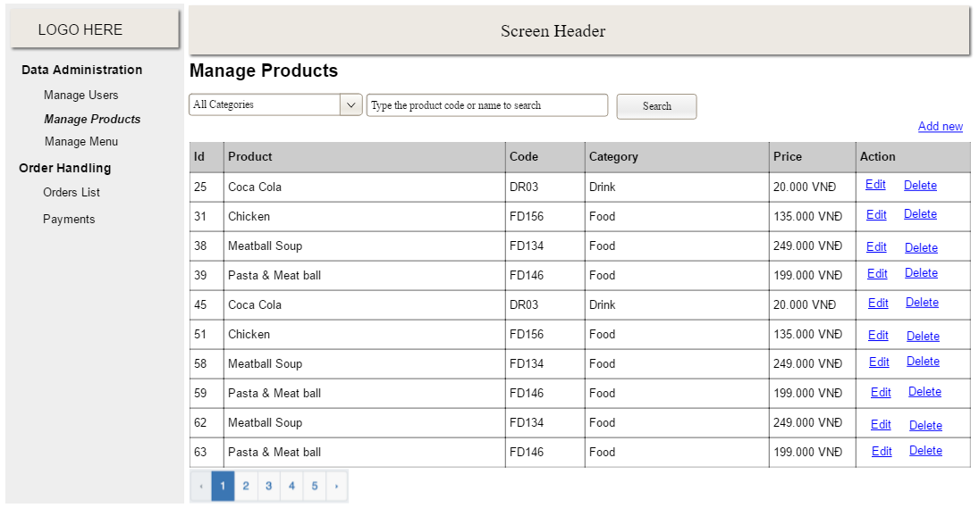

* *Function Details: provide explanation for the data, validation, business logics, functionalities (for both normal cases and abnormal cases), etc. of the function so that the reader can image how it work.*

*]*

### b. <<Function Name 2>>

…

## 2. <<Feature Name 2>>

…